Experiment Details

|  |  |
| --- | --- |
| Department Name | Electrical engineering |
| Class | TY BTech |
| Semester | V |
| Subject Name | Feedback Control System |
| Experiment No. | 01 |
| Experiment Name | Obtaining Transfer Function of a system & block diagram reduction |

Version History

|  |  |  |  |  |
| --- | --- | --- | --- | --- |
| Sr. No. | Version Number | Created By | Approved By | Date |
| 1 | v1.0 | Yuvraj Bhalekar | Mrs. Sushmita Amit Sarkar | 10/10/2020 |
|  |  |  |  |  |

AIM:

Calculation of transfer function for a given set of poles and zeros and reduction of block diagram to find overall transfer function using MATLAB programming.

THEORY:

The transfer function of a system be represented as G(s)

G(s) = $\frac{Vo(s) }{ Vi(s)}$

Or generally G(s) = $\frac{C(s) }{ R(s)}$

Where C(s) is Laplace transform of output

R(s) is Laplace transform of input

Both C(s) and R(s) are polynomials in s

i.e, G(s)= $\frac{k\left(s-b1\right)\left(s-b2\right)\left(s-b3\right)\left(s-b4\right)…………..(s-bm)}{\left(s-a1\right)\left(s-a2\right)\left(s-a3\right)\left(s-a4\right)……………(s-an)}$

**Poles:** Poles of a transfer function are the values of the Laplace transform variable s, that causes the transfer function to become infinite. In above equation, when s=a1, s=a2, s=a3……s=an, the transfer function G(s) becomes infinite. Hence a1, a2, a3……an are the poles of the transfer function. If we equate the denominator of the transfer function to zero, we obtain the pols of the system.

**Zeros:** Zeros of a transfer function are the values of the Laplace transform variable s, that causes the transfer function to become zeros. In above equation, when s=b1, s=b2, s=b3……s=bm, the transfer function G(s) becomes equal to zero. Hence b1, b2, b3……….bm are the zeros of the transfer function. If we equate the numerator of the transfer function to zero, we obtain the zeros of the system.

**Rules for Block Diagram Reduction:**

**Rule 1: BLOCKS IN SERIES OR CASCADE**

Any finite number of blocks in series may be algebraically combined by multiplication

**C(S)**

**G2**

**G1**

**R(s)**

**C(S)**

**G1G2**

**R(s)**

**Rule 2: BLOCKS IN PARALLEL**

The blocks which are connected in parallel get added algebraically (considering the sign of polarity)

**G1**

**C(s)**

**R(s)**

**G2**

**G3**

**C(s)**

**G1+G2-G3**

**R(s)**

**Rule 3: ELIMINATE FEEDBACK LOOP**

To eliminate the feedback loops we use the closed loop transfer function derivation

**E(s)**

**R(s)**

**C(s)**

**G**

**±B(s**)

**H**

$\frac{C\left(s\right)}{R\left(s\right)}$ = $\frac{G(s)}{ 1 ±G\left(s\right)H(s)}$

$\frac{C\left(s\right)}{R\left(s\right)}$ = $\frac{G(s)}{ 1+G\left(s\right)H(s)}$ for negative feedback

$\frac{C\left(s\right)}{R\left(s\right)}$ = $\frac{G(s)}{ 1-G\left(s\right)H(s)}$ for positive feedback

PRE-TEST:

(Answers are in bold)

1. Blocks in series can be……
   1. **Algebraically added**
   2. Multiplied
   3. Kept as it is
2. Poles of a transfer function are……
   1. **The values of the Laplace transform variable S that causes the transfer function to become infinite**
   2. The values of the Laplace transform variable S that causes the transfer function to become zero
   3. None of the above
3. Zeros of a transfer function are……
   1. The values of the Laplace transform variable S that causes the transfer function to become infinite
   2. **The values of the Laplace transform variable S that causes the transfer function to become zero**
   3. None of the above
4. Transfer function of system is….
   1. **G(s) = $\frac{C(s) }{ R(s)}$**
   2. G(s) = $\frac{R(s) }{ C(s)}$
   3. None of the above

PROCEDURE:

**1. The control system is represented in zero-pole form ,Z = [-1, -2], P = [0, -3 , -5 ,-7] &**

**K = 4. Obtain the system transfer function.**

**MATLAB CODE:**

clc; clf; close all;

Z = [-1; -2]

P = [0, -3, -5, -7]

K = 4

[num,den] = zp2tf(Z,P,K)

disp(‘Transfer Function of Control System : ’)

G = tf(num,den)

**2.If $G1=\frac{3s}{s+2}$ and $G2=\frac{7}{s^{2}+5s+13}$**

**Find: G1 and G2 connected in series.**

**G1 and G2 connected in parallel.**

**G1 and G2 connected in feedback.**

**MATLAB CODE:**

n1=[3 0];d1=[1 2];

G1=tf(n1,d1)

n2=[7];d2=[1 5 13];

G2=tf(n2,d2)

sys1=series(G1,G2)

sys2=parallel(G1,G2)

sys3=feedback(G1,G2,+1)

sys4=feedback(G1,G2,-1)

sys5=feedback(G1,G2)

**3.Reduce the following block diagram using MATLAB.**

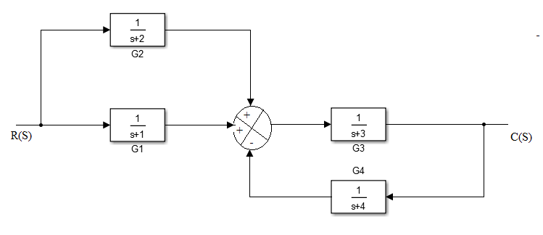

**MATLAB CODE:**

n1=[1];d1=[1 1];

G1=tf(n1,d1)

n2=[1];d2=[1 2];

G2=tf(n2,d2)

sys1=parallel(G1,G2)

n3=[1];d1=[1 3];

G3=tf(n3,d3)

n4=[1];d2=[1 4];

G4=tf(n4,d4)

sys2=feedback(G3,G4)

sys3=series(sys1,sys2)

1. Start simulation
2. Click on next problem to got to the next problem
3. Click on run to get output

POST TEST:

(Answers are in bold)

1. What is transfer function of the following block diagram

R(S) G1 G2 C(S)

* 1. **G1+G2**
  2. G.G2
  3. G1/G2
  4. None of the above

1. What is transfer function of the following block diagram

R(S) **-** G1 G2 C(S)

H

* + - * 1. **(G1+G2) / [1+H(G1+G2)]**
        2. (G1+G2) / G1G2
        3. (G1+G2) / H.G1.G2
        4. None of the above

1. What is transfer function of the following block diagram

R(S) **-** G1 G2 C(S)

G3

H

* + - * 1. **(G1+G2+G3) / [1+H(G1+G2+G3)]**
        2. (G1+G2+G3) / G1G2
        3. (G1+G2) / H.G1.G2.G3
        4. None of the above

1. How to obtain zeros of transfer function
   1. By equating the denominator to zero
   2. **By equating the numerator to zero**
   3. By equating the denominator to 1
   4. By equating the numerator to 1

REFERENCES:

Write names of text books and reference books for experiment.